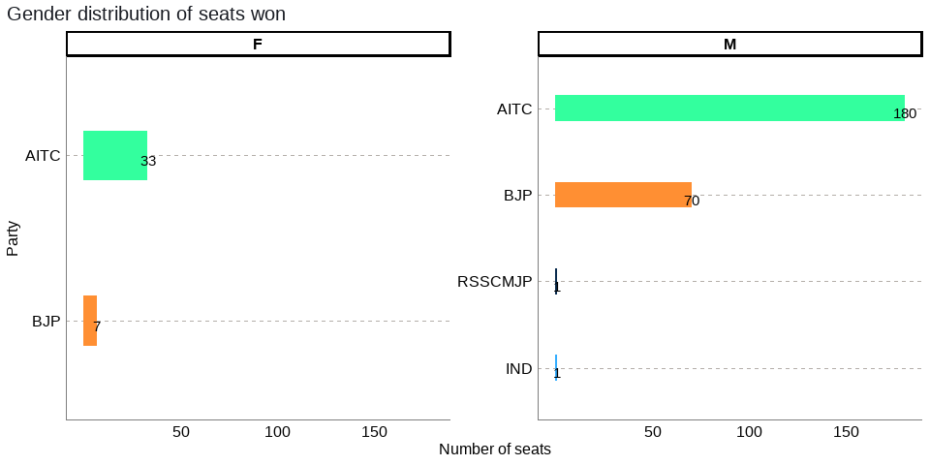 Figure 13: The Gender split of Winner candidates by party

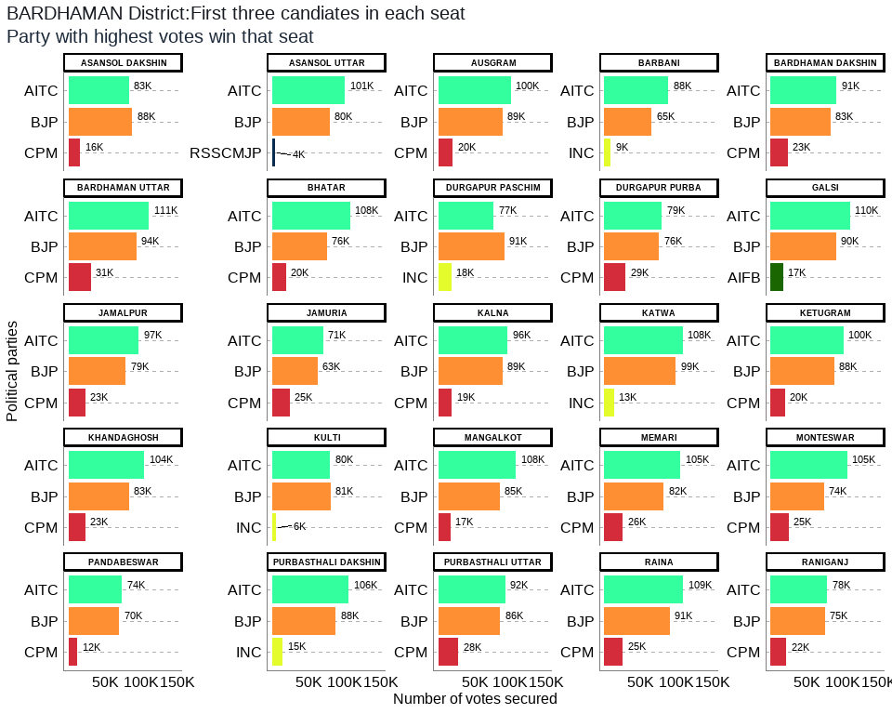

Figure 16: Bardhaman District: Winners per constituency and top 3 candidates

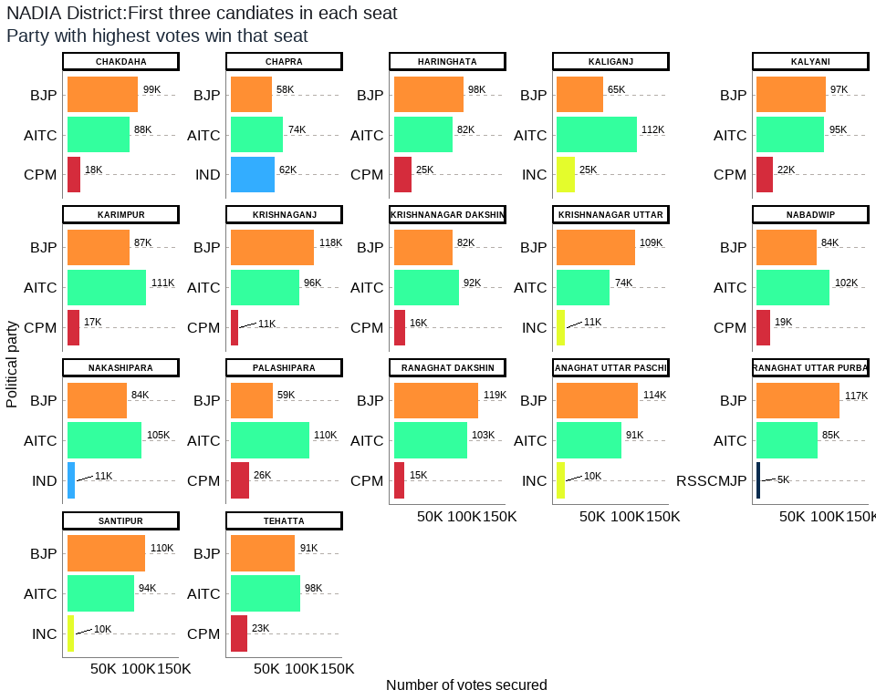

Figure 27: Nadia District: Winners per constituency and top 3 candidates